TEAM IDENTITY AND CONTRACT OUTLINE
The Team Identity and Contract needs to include all the items, in the order that they appear, in the checklist below. Additionally, the document needs to have a format and style that is consistent throughout and be free from grammar errors.
Team Identity:
- Unique team name – Aggie Baja Controls (ABC)
- Distinctive team logo –

Team Information:
- Labeled team photo
  - 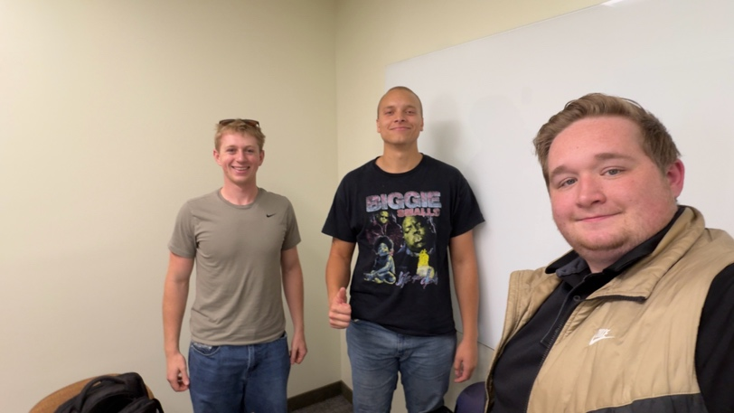
  - Ben (Left), Jacob (Middle), Alex (Right)
- List of team contact information (name, phone number, and email address for each team member) – Identify which student will be the primary point of contact between the team and the sponsor
  - Primary Point of Contact – Jacob
  - Jacob – 818-303-5217 – A02365516@usu.edu
  - Ben – 801-897-6675 - A02408223@aggies.usu.edu
  - Alex – 801-931-9581 – alex.miller@usu.edu
- Weekly meeting information (day, time, and location and/or video conference link)
  - Weekly on Thursdays at 4:00 either in the ENGR Computer Lab or Online via Zoom.
Team Contract:
- Goals
  - What are your team’s goals for the collaboration? - These should relate to the team’s performance on the project as well as the processes that the team will follow to complete the project. What are your team’s expectations regarding the quality and timeliness of the team’s work?
    - Produce a functioning “Drivetrain and Communication system” for the Baja
    - Be efficient.
    - Be on time, and if you can’t communicate it!
- Roles
  - Who is responsible for each activity? What roles will each member have? - Don’t forget to include logistical tasks, such as arranging meetings, preparing agendas and meeting minutes, and team process roles, such as questioning (devil’s advocate), ensuring that everyone’s opinion is heard, etc.
    - Alex – Communication/Electrical/UX-UI
    - Jacob – Primary Contact/Steering/FWD Engagement
    - Ben – Throttle/Brake Systems
    - Rotating Assignments – Agendas/Meeting Logistics/Minutes
- Attendance
  - What are your team’s expectations regarding meeting attendance (being on time, leaving early, missing meetings, etc.)?
    - Be on time and just communicate.
    - Be actively engaged
- Excuses
  - What constitutes an acceptable excuse for missing a meeting or a deadline? What types of excuses will not be considered acceptable?
    - Non-acceptable excuses are pretty much limited to “I didn’t want to”
    - Just Communicate!
    - No Call/No Show is not favorable.
- Emergency Process
  - What process will team members follow if they have an emergency and cannot attend a team meeting or complete their individual work promised to the team (deliverable)?
    - Email, text, communicate as soon as possible
- AI Use
  - What are your team’s expectations regarding team members’ use of AI?
    - As long as you understand what it’s doing and understand what it’s doing it’s free game. (AI-4) We still remain personally accountable for any output from Artificial Intelligence.
- Preparation
  - What are your team’s expectations regarding the quality of team members’ preparation for team meetings and the quality of the deliverables that members bring to the team?
    - “Be prepared”
    - Have ideas on what you would like to discuss
    - Picture or physical proof of progress
- Contributions
  - What are your team’s expectations regarding team members’ ideas, interactions with the team, cooperation, attitudes, and anything else regarding team-member contributions?
    - Be Nice
    - Work with others
    - Don’t be afraid to be honest
    - “I can’t make adjustments if I don’t know there needs to be adjustments.”
    - Always approach critique with an improvement mindset.
- Monitoring
  - What methods will be used to keep the team on track? How will your team ensure that members contribute as expected to the team and that the team performs as expected? How will your team reward members who do well and manage members whose performance is below expectations?
    - Keep track – weekly meetings (deliverables, discussion items, etc.)
    - Rewarded – Degrees, Grades, and new friends
    - Below Expectation – Be honest and blunt. Involve Dr. Graham if absolutely necessary.
- Signatures of every team member signifying that they agree to the terms of the team generated contract
  - Alexander Miller – 09/17/26
  - Jacob Gilliam – 09/17/26
  - Benjamin McGuire – 09/17/26

